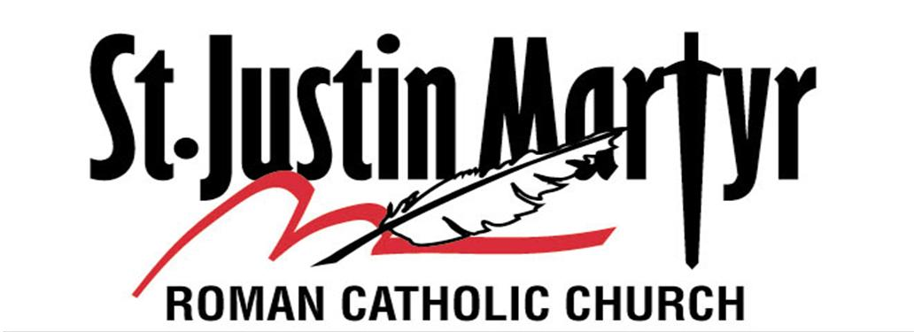

Life Foundations REGISTRATION

Fall 2024/Spring 2025

Please provide a copy of a baptismal certificate for all new registrations if the child was baptized at a church other than St. Justin, Martyr.

Parent Information:
Mother’s Name: Cell Phone # ____________________Religion: ____________
Father’s Name: Cell Phone # ____________________Religion: ____________
(Legal Guardian Name): Cell Phone # ____________________Religion: ____________
Home Address: ________________________________________ City: ___________________, FL __________
Best Email Address:__________________________________Best Phone # for text messages:_____________________
What Mass Time does family usually attend: ________________
Child(ren) Information:
Name: Last____________________________First_____________________________Middle______________________
Gender:_________Date of birth:___/___/___ School:__________________________________________Grade:_______
List Parish name and Date received Baptism:_____________________________________________________________
List Parish name and Date received Eucharist:____________________________________________________________
Child(ren) Information:
Name: Last____________________________First_____________________________Middle______________________
Gender:_________Date of birth:___/___/___ School:__________________________________________Grade:_______
List Parish name and Date received Baptism:_____________________________________________________________
List Parish name and Date received Eucharist:____________________________________________________________
Child(ren) Information:
Name: Last____________________________First_____________________________Middle______________________
Gender:_________Date of birth:___/___/___ School:__________________________________________Grade:_______
List Parish name and Date received Baptism:_____________________________________________________________
List Parish name and Date received Eucharist:____________________________________________________________
Emergency Contact Information
Name:______________________________Relationship to child:___________________Phone #:___________________
Name:______________________________Relationship to child:___________________Phone #:___________________

Is there any other information about your child/children we need to know to be of better assistance to your family?
For example: Health issues, allergies, learning challenges, special needs, areas of sensitivity, special family circumstances, etc. All information on this form is kept confidential. _______________________________________________________
__________________________________________________________________________________________________
TIME AND TALENT: Lifelong Faith Formation in our parish can only exist through the generous stewardship of our parish families. Which of the following areas can you assist us with during the year; please check all that apply:
___Catechist ___Catechist Assistant ___First Communion/Confirmation ___ Youth Ministry
___Arts & Crafts ___Substitute Catechist ___Clerical/Office Volunteer ___ Music
REGISTRATION FEE:
$75* for the first child, $65* for 2nd child, $60* for each additional child.
Checks should be made out to St. Justin, Martyr Catholic Church.
*Parents who complete a minimum of 3 volunteer hours will receive a partial refund.
PARENT/GUARDIAN CONSENT: I/We consent to my/our child being registered in St. Justin, Martyr Life Foundations. I/We understand/believe in this formation, Christianity is presented according to the teachings of the Roman Catholic Church. I/We also understand, as primary catechist(s) for my child, I/we assume responsibility for their attendance, behavior, and meeting the necessary guidelines for the curriculum. I/We also understand weekly Mass attendance will greatly enhance and form my child in this learning experience through faith formation and is a requirement as stated in the commandments. This teaching of the child does not replace participation in the Eucharistic celebration with the St. Justin, Martyr parish community.
I acknowledge I have received, read, understand, and my child agrees to abide by the policies contained in the Life Foundations/Faith Formation Handbook including the local parish program policies and procedures, the Harassment Policy in Non-Employment Situations, and the Safe Environment Policies of the Diocese of St. Petersburg.
Please check all that apply, sign, date as appropriate in the spaces provided.
__ I will attend the Parent/Student Safe Environment Education Program sessions as scheduled.
__ I cannot attend the Parent/Student Safe Environment Education Program, but I wish to receive all additional
(beyond the handbook policies) materials related to the Safe Environment Parent/Student Education Program.
MEDICAL. I request the parish representative obtain medical treatment for my child in the unlikely event of injury or illness during this event, and I agree to pay any expenses incurred for such treatment. If the Church is unable to reach the parent/guardian, or any other person designated, I hereby authorize the Church and its representatives to contact my child’s physician and/or make arrangements for immediate emergency treatment.
This medical release is valid from August 1, 2024 until July 31, 2025 and for all events throughout the year.
Family Physician Name: Phone:
Medications taken daily and/or regularly:
Health Problems:
Insurance Information: Insurer: Group #:
Other Medical Treatment. In the event my child becomes ill with symptoms such as headaches, vomiting, sore throat, fever, diarrhea, we will contact the parent or guardian before administering any medication.
My child may be given: Tylenol______ Ibuprofen Throat lozenges Benadryl ________
If you have any questions, please contact the Life Foundations office by phone at: 727-397-3312 ext. 306, or by email at; kbobak@stjustinmartyr.net

State of Florida, County of ___________________________
The foregoing was acknowledged before me this____________day of_________________,20_____

By__________________________________Personally known_____Or Produced Identification______________________________
________________________________________ _____________________
Name of Parent/Guardian Date

Notary Seal ________________________________________ _____________________
Signature of Parent/Guardian Date
Signature of Notary
OFFICE USE ONLY: Fee Paid: ____ Check #:______ Amt. Paid:____ Baptism Cert:____ 7/29/24

PARISH MEDIA RELEASE
Child(ren) Information:
Name: Last____________________________First_____________________________Middle______________
Child(ren) Information:
Name: Last____________________________First_____________________________Middle______________
Child(ren) Information:
Name: Last____________________________First_____________________________Middle______________
Child(ren) Information:
Name: Last____________________________First_____________________________Middle______________
PROMOTIONAL MEDIA RELEASE: During the Life Foundations School Year, my child(ren), listed above, may participate in videotape, motion picture, audio recording or still photograph productions that involve the use of students’ names, likenesses or voices. Such productions may be used for educational or exhibition purposes by St. Justin, Martyr in perpetuity and may be copied, copyrighted, edited and distributed by St. Justin, Martyr in perpetuity unless said consent is revoked in writing.
News media, including representatives of television, radio, newspapers and magazines, are also often permitted on parish property and may take notes, still photos, sound recordings and/or moving pictures that may include your child. These items may appear or be used in news or feature stories by print, television or radio media.
You have the right to object to the use of your child’s name, picture or voice in these productions and may do so by making a selection in the paragraph below and returning it to the Life Foundations Office.
I/We, the undersigned, do/do not (Circle One) hereby consent: St. Justin, Martyr, may use the name, portrait, or other likeness of my child for parish bulletin boards, website, news releases, media and promotional activities. This consent is renewed at the beginning of each Life Foundations School Year.
2021-2022 Registration Form English

________________________________________
Signature of Parent/Guardian
S://Life Foundations 2024-2025 Registration Form English
7/29/24

