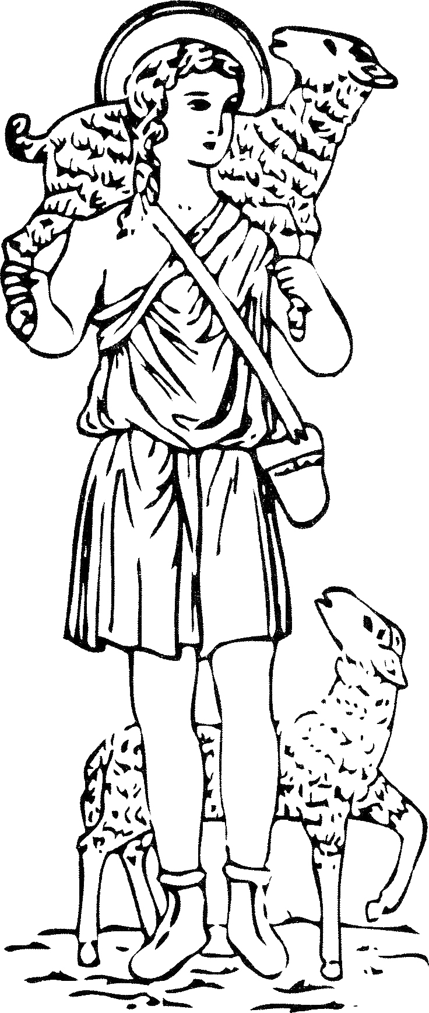
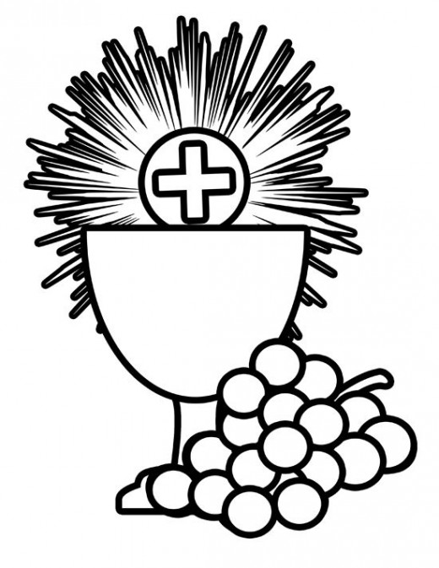
St. Justin, Martyr Church

1st Holy Eucharist and Reconciliation

Fall 2024/Spring 2025

Parent or legal guardian must complete this form and submit the document(s) listed below for their child

to receive the sacrament of First Holy Eucharist and First Reconciliation at St. Justin, Martyr Church.

PLEASE ATTACH/INCLUDE A COPY OF BAPTISMAL CERTIFICATE
Child’s Name: Last____________________________First__________________________Middle___________________
Home Address: ____________________________________________________________________________________
Street City State Zip
Place of Birth: _______________________________________________Full Date of Birth: _______/_________/_______
City State month day year
School Attending: __________________________________________________________________________________
Full Date and Church of Baptism: ______________________________________________________________________
Church Address: ___________________________________________________________________________________
Street City State Zip
Contact Information:
Phone: _____________________________________Email: ________________________________________________
Mother’s First Name: _________________________________Maiden Name: ___________________________________
Father’s First Name: _________________________________Last Name: ______________________________________
I understand that we (our child and rest of family) are entering into a time of preparation to receive the Sacraments of Reconciliation and Holy Eucharist for the first time. We realize it is important to attend all the sessions and the retreat for both these sacraments.

The preparation period begins in late fall with a parent informational meeting. Besides the preparation classes for these sacraments, there will be a retreat in late April/early May for these sacraments. The Sacrament of Holy Eucharist will be celebrated in May 2025, at the 9:00 am Mass. The sacrament of Reconciliation will be administered in the weeks prior to the First Eucharist date. The Sacrament Preparation fees for these sacraments are $75. The schedule for classes will be presented at the Parents meeting for First Communion.

___________________________________________
Printed Name of Parent/Guardian
___________________________________________ ________________________________________
Signature of Parent/Guardian Date

Additional Required Documents/Information
Registration/Materials Fee: $75
Copy of Baptismal Certificate

8/22/24

